Tab 1

**Case Studies & Guesstimates for Healthcare Industries**

The healthcare industry is a cornerstone of society, providing essential services that ensure the well-being and health of populations worldwide. In today's era, its importance has been underscored by the rapid advancements in medical technology and the increasing demand for quality healthcare services. The industry faces numerous challenges, including rising costs, ageing populations, and the need for more efficient patient care.

Data scientists play a pivotal role in addressing these challenges, leveraging their expertise to analyse vast amounts of healthcare data. They help in predicting disease outbreaks, personalising treatment plans, and improving patient outcomes through predictive analytics. Additionally, data scientists optimise hospital operations, enhance diagnostic accuracy with machine learning algorithms, and contribute to the development of new medical treatments and drugs. By harnessing the power of data, they drive innovation, improve efficiency, and ensure the delivery of high-quality healthcare services, making a significant impact on the industry's growth and sustainability.

**PART - I**

**Product Dissection**

**1. Platform Selection**

Tata 1mg is a leading digital healthcare platform in India, offering a comprehensive range of services including online pharmacy, diagnostics, teleconsultation, and health content. It plays a crucial role in making healthcare accessible and affordable for millions of people across the country. Tata 1mg, formerly known as 1mg, is a prominent digital healthcare platform based in Gurugram, India. Established in April 2015 by Prashant Tandon, Gaurav Agarwal, and Vikas Chauhan, the platform has significantly transformed the Indian healthcare landscape by integrating technology with medical services. It was founded in 2015 and later acquired by Tata Digital in 2021.



1. **Popularity & Reach**

* Tata 1mg is one of the most trusted online healthcare platforms in India, with millions of users relying on it for medicines, lab tests, and doctor consultations.
* The platform is backed by Tata Digital, which adds credibility and strengthens its position in the market.

**2.**  **Impact on the Healthcare Industry**

* **Affordable Medicines:** Tata 1mg offers a wide range of medicines, including generics, at competitive prices, making healthcare more affordable.
* **Diagnostics & Lab Tests:** It provides home sample collection services for lab tests, enhancing convenience for patients.
* **Teleconsultation:** The platform enables users to consult certified doctors online, reducing the need for physical hospital visits.
* **Health Awareness:** Through its rich database of medicine details, health blogs, and expert advice, it empowers users with valuable health knowledge.

**3.** **Relevance in the Industry**

* **Bridging Gaps in Healthcare Access:** It connects patients with doctors and diagnostic services in both urban and rural areas.
* **Tech-Driven Healthcare Solutions:** The platform leverages AI and data analytics to provide medicine recommendations, track health conditions, and optimize supply chain operations.
* **Scalability & Future Growth:** With an increasing demand for digital healthcare, Tata 1mg is well-positioned to expand its services and reach a larger audience.

**2. Core Features and Functionalities**

**Core Features and Functionalities of Tata 1mg**

Tata 1mg is a comprehensive digital healthcare platform that provides a range of services, making healthcare more accessible, affordable, and efficient. Below are the core features and functionalities that contribute to its success and user engagement:

**1. Online Pharmacy (E-Pharmacy)**

**Feature:** Users can order medicines, OTC products, and healthcare essentials online.  
**Functionality:**

* Search for medicines by name, composition, or category.
* Compare generic alternatives for cost-effective options.
* Upload prescriptions for hassle-free medicine ordering.

**Impact:** Enhances affordability and convenience by delivering medicines to users’ doorsteps, especially benefiting elderly and chronic patients.

**2. Teleconsultation with Doctors**

**Feature:** Enables users to consult verified doctors online across various specializations.  
**Functionality:**

* Choose doctors based on specialty (e.g., general physician, dermatologist, cardiologist).
* Video, audio, and chat consultations for medical advice and second opinions.
* Digital prescriptions after consultations.

**Impact:** Improves healthcare accessibility, especially for rural areas where medical specialists may not be available.

**3. Medicine Information & Health Content**

**Feature:** Comprehensive database of medicines, including their uses, side effects, dosage, and substitutes.  
**Functionality:**

* Search for medicines to understand their compositions and possible interactions.
* Read expert health blogs, disease guides, and wellness tips.
* AI-powered health insights and recommendations.

**Impact:** Empowers users with knowledge to make informed healthcare decisions, improving medication adherence and safety.

**4. AI-Driven Health Recommendations**

**Feature:** AI-powered medicine reminders and health trackers.

**Functionality:**

* Set reminders for taking medicines on time.
* Track health parameters like blood pressure, sugar levels, and BMI.
* Get AI-based alerts for potential drug interactions.

**Impact:** Improves medication adherence and helps users manage chronic conditions effectively.

**5. User-Friendly Mobile App & Website**

**Feature:** Seamless mobile app and web interface for easy navigation.  
**Functionality:**

* Personalized dashboards with order history, prescriptions, and health records.
* Secure payment options, including UPI, wallets, and net banking.

**Impact:** Enhances user experience with a smooth and intuitive interface, increasing platform adoption.

**3. Real World Problems**

Tata 1mg addresses several critical healthcare challenges in India, ranging from accessibility and affordability to medication safety and preventive care. Below are the key real-world problems the platform aims to solve and how its features effectively tackle them.

**1. Lack of Accessibility to Medicines and Healthcare Services**

**Problem:**

* Many people, especially in rural areas, struggle to access essential medicines, lab tests, and doctors due to geographical barriers.
* Limited availability of specialized doctors in remote locations.
* Branded medicines are costly, and many people are unaware of affordable generic alternatives.

**Solution by Tata 1mg:**

* **Generic Medicine Alternatives:** Offers lower-cost generic substitutes for branded medicines.
* **Discount Programs & Tata 1mg Plus Membership:** Provides discounts on medicines, consultations, and lab tests.
* **Price Comparisons:** Users can compare prices of different medicines before purchasing.

**Impact:** Reduced medical expenses for users, making healthcare more affordable and accessible.

**2. Lack of Medicine Awareness and Safety Concerns**

**Problem:**

* Patients often lack knowledge about proper medication usage, side effects, and drug interactions.
* Many individuals self-medicate without proper guidance, leading to health risks.

**Solution by Tata 1mg:**

* **Medicine Information Database:** Provides detailed descriptions of medicines, including uses, side effects, and dosages.
* **AI-Based Drug Interaction Alerts:** Warns users about potential risks when taking multiple medications.
* **Health Blogs & Doctor Advice:** Educates users on common health conditions and safe medication practices.

**Impact:** Improved medication adherence and reduced health risks due to self-medication.

**3. Time Constraints and Inconvenience of Visiting Healthcare Facilities**

**Problem:**

* Busy professionals and elderly patients often struggle to visit doctors and pharmacies.
* Long waiting times at hospitals and clinics lead to delays in treatment.

**Solution by Tata 1mg:**

* **Online Doctor Consultations:** Users can book virtual appointments with doctors at their convenience.
* **Home Delivery of Medicines:** Eliminates the need for pharmacy visits.
* **Home Sample Collection for Lab Tests:** Saves time and effort by providing at-home diagnostics.

**Impact:** Increased convenience, faster treatment access, and reduced hospital congestion.

**4. Rise in Chronic Diseases and Need for Preventive Healthcare**

**Problem:**

* Chronic conditions like diabetes, hypertension, and heart diseases require regular monitoring.
* Lack of preventive healthcare awareness leads to late diagnosis of serious conditions.

**Solution by Tata 1mg:**

* **Health Monitoring Features:** Allows users to track blood sugar, blood pressure, and other vitals.
* **Preventive Health Checkups:** Offers diagnostic packages for early disease detection.
* **Reminders for Medication & Appointments:** Ensures adherence to treatment plans.

**Impact:** Encourages preventive healthcare and improves chronic disease management.

### **5. Limited Access to Authentic Healthcare Advice**

**Problem:**

* Many people rely on unreliable sources like social media and word-of-mouth for health advice, leading to misinformation.
* Patients often struggle to find verified doctors and specialists for second opinions.
* There is a lack of personalized guidance on nutrition, fitness, and overall well-being.

**Solution by Tata 1mg:**

* **Verified Doctor Network:** Connects users with qualified doctors for expert consultations.
* **AI-Powered Health Chatbot:** Provides instant responses to common health queries based on medical databases.
* **Personalized Health & Wellness Plans:** Offers expert-guided plans on diet, exercise, and lifestyle improvements.

**Impact:**

* Reduces misinformation and promotes evidence-based healthcare decisions.
* Helps users make informed choices about their health and well-being.
* Increases trust in digital healthcare services.

**Database Management & Schema Design**

**4. Schema Design**

### **Schema Design for Tata 1mg**

The schema for Tata 1mg should cover essential features such as **User Management, E-Pharmacy, Teleconsultation, Lab Tests, and Order Processing**. Below is the **Entity-Relationship (ER) Diagram Structure** along with entity descriptions.

## **Key Entities & Attributes**

### **1. Users Table (Stores user information)**

* **user_id** (PK) – Unique identifier for each user
* **name** – Full name of the user
* **email** – Email address (Unique)
* **phone_number** – Contact number
* **address** – User’s delivery address
* **date_of_birth** – User’s birthdate
* **gender** – Male/Female/Other
* **password_hash** – Encrypted password for login
* **created_at** – Account creation timestamp

### **2. Medicines Table (Stores medicine details)**

* **medicine_id** (PK) – Unique identifier for each medicine
* **name** – Name of the medicine
* **composition** – Active ingredients
* **category** – Type (e.g., Pain Relief, Antibiotic, Diabetes, etc.)
* **price** – Price per unit
* **availability_status** – In stock or out of stock
* **manufacturer** – Name of the manufacturing company
* **expiry_date** – Expiry date of the medicine
* **description** – Usage details, precautions, and side effects

### **3. Orders Table (Tracks medicine orders)**

* **order_id** (PK) – Unique identifier for each order
* **user_id** (FK) – User placing the order
* **order_date** – Date of order placement
* **total_amount** – Total cost of the order
* **order_status** – Pending, Shipped, Delivered, Cancelled
* **payment_status** – Paid, Pending, Failed
* **delivery_address** – Address for order delivery

### **4. Order_Items Table (Stores details of items in an order)**

* **order_item_id** (PK) – Unique identifier for each item in an order
* **order_id** (FK) – Order to which this item belongs
* **medicine_id** (FK) – Medicine being purchased
* **quantity** – Number of units ordered
* **price** – Price per unit

### **5. Doctors Table (Stores information about doctors for teleconsultation)**

* **doctor_id** (PK) – Unique identifier for each doctor
* **name** – Doctor’s name
* **specialization** – Area of expertise (e.g., Dermatology, Cardiology)
* **experience** – Years of experience
* **consultation_fee** – Fee per consultation
* **availability_status** – Available/Unavailable
* **rating** – Average user rating

### **6. Appointments Table (Tracks doctor consultations)**

* **appointment_id** (PK) – Unique identifier for each consultation
* **user_id** (FK) – User booking the consultation
* **doctor_id** (FK) – Doctor assigned to the consultation
* **appointment_date** – Date and time of consultation
* **consultation_mode** – Video, Audio, Chat
* **status** – Scheduled, Completed, Cancelled
* **prescription** – Link to prescription generated after consultation

### **7. Lab_Tests Table (Stores diagnostic test details)**

* **test_id** (PK) – Unique identifier for each test
* **name** – Name of the diagnostic test (e.g., Blood Sugar, Thyroid Test)
* **category** – Type of test (e.g., Blood Test, Urine Test)
* **price** – Cost of the test
* **description** – Test details, precautions, and sample requirements

### **8. Lab_Orders Table (Tracks lab test bookings)**

* **lab_order_id** (PK) – Unique identifier for each lab test booking
* **user_id** (FK) – User booking the test
* **test_id** (FK) – Lab test selected
* **booking_date** – Date and time of test booking
* **sample_collection_date** – Scheduled date for home sample collection
* **test_status** – Pending, In Process, Completed
* **result_url** – Link to test report

### **9. Payments Table (Manages payment transactions)**

* **payment_id** (PK) – Unique transaction identifier
* **user_id** (FK) – User making the payment
* **payment_date** – Date and time of transaction
* **amount** – Amount paid
* **payment_method** – Credit Card, UPI, Net Banking, Wallet
* **payment_status** – Successful, Pending, Failed

### **10. Reviews & Ratings Table (Stores user feedback)**

* **review_id** (PK) – Unique identifier for each review
* **user_id** (FK) – User who posted the review
* **entity_id** – ID of medicine, doctor, or lab test being reviewed
* **entity_type** – Medicine, Doctor, Lab Test
* **rating** – 1 to 5 stars
* **review_text** – User’s feedback
* **review_date** – Date of review submission

## **Relationships Between Entities**

* **Users** can place multiple **Orders** and **Lab Test Bookings**.
* Each **Order** contains multiple **Medicines**.
* **Users** can book **Doctor Appointments** for teleconsultation.
* **Doctors** provide **Consultations** and generate **Prescriptions**.
* **Users** make **Payments** for **Orders, Appointments, and Lab Tests**.
* **Users** can give **Reviews & Ratings** for **Medicines, Doctors, and Lab Tests**.

## **Conclusion**

This schema effectively captures Tata 1mg’s key functionalities, ensuring efficient data management for **online pharmacy, doctor consultations, lab tests, orders, and payments**. The relationships between entities support seamless integration of services, enhancing user experience and platform efficiency.

**5. ER Diagram Creation**

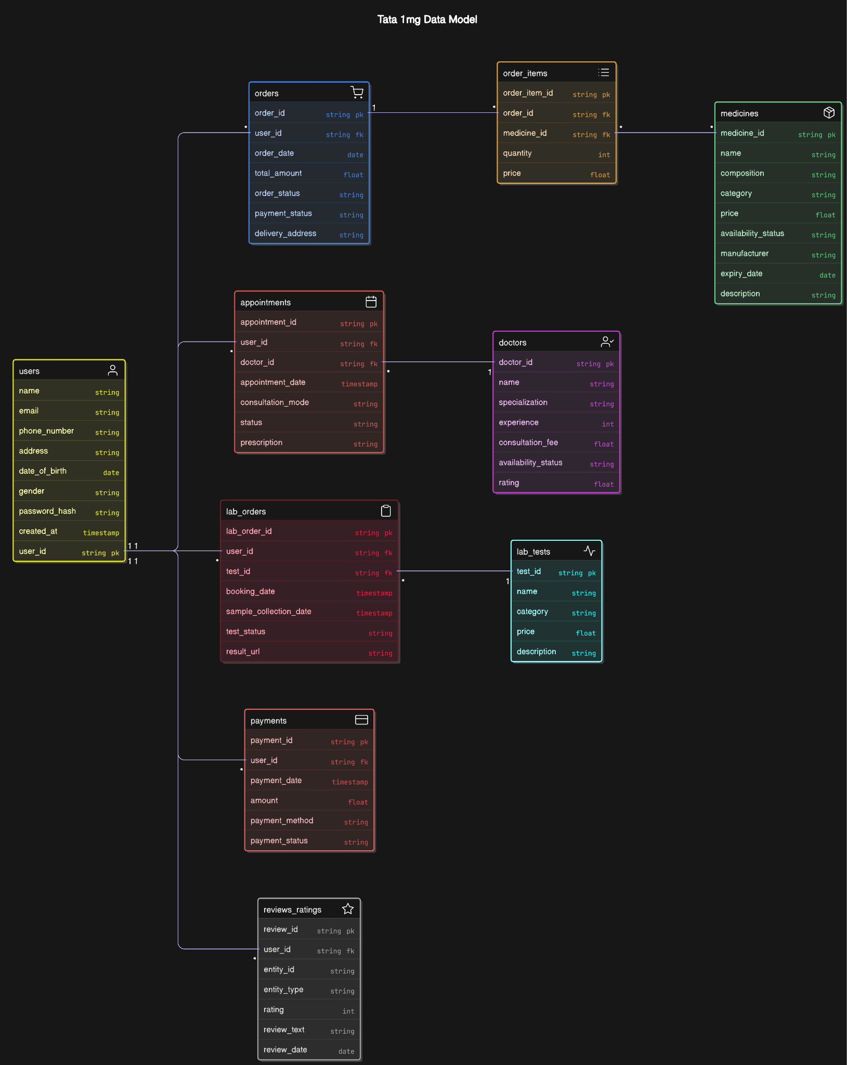

**Revenue and Profit Growth Strategies**

Tata 1mg is one of India's leading digital healthcare platforms, offering e-pharmacy services, diagnostic tests, and teleconsultations. In recent years, the company has witnessed substantial growth, but achieving profitability remains a challenge. This case study aims to propose strategies to increase Tata 1mg's profit by at least 25%, backed by financial data and industry trends.

#### **I. Analyzing Tata 1mg's Current Financial Status**

Examining Tata 1mg’s revenue, expenses, and profitability trends is crucial to devise effective strategies.

| **Current Financial Data** | **Revenue:** The total revenue amounts to ₹1968 crore, with the sale of medicines contributing the largest share at ₹1599.985 crore. Lab tests account for ₹218 crore, while advertisements bring in ₹42 crore. Other sources, including the patient support program and shipping, add ₹108 crore. |
| --- | --- |
| **Expenses:** The total expenses amount to ₹2304 crore, with ₹1290 crore spent on the procurement of medicines. Employee benefit expenses total ₹373 crore, while advertising costs reach ₹135.2 crore. Other expenses, including legal and professional charges, secondary packing, commissions, and IT, contribute ₹505.8 crore. |
| **Loss/Profit:** The company incurred a loss of ₹313 crore, as total expenses exceed total revenue. |

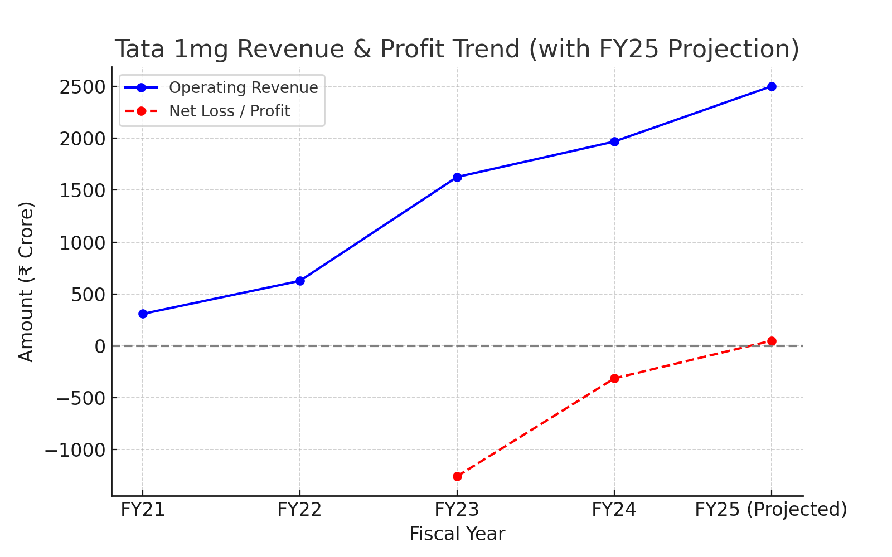

**Fig. 1: Revenue and Profit Trend of Tata 1mg**

**Sources of Revenue:**

| **Sale of Medicines (₹1599.985 crore)** | **Contribution**: This is the largest revenue stream, accounting for approximately 81.3% of the total revenue. |
| --- | --- |
| **Analysis**: The dominance of medicine sales indicates that the business heavily relies on pharmaceutical product sales. |
| **Lab Tests (₹218 crore)** | **Contribution**: Lab tests contribute around 11.1% to the total revenue. |
| **Analysis:** While smaller than medicine sales, this segment plays a key role in diversifying revenue sources. |
| **Advertisement Revenue (₹42 crore)** | **Contribution**: Advertisements account for about 2.1% of the revenue. |
| **Analysis**: This relatively small portion suggests limited revenue from marketing services. |
| **Others (Patient Support Programs and Shipping) (₹108 crore)** | **Contribution**: This segment contributes around 5.5% of the total revenue. |
| **Analysis**: Revenue from patient support programs and shipping indicates the company’s involvement in value-added services. |

**Sources of Expenses:**

| **Cost of Procurement of Medicines (₹1290 crore)** | **Contribution**: This is the largest expense, accounting for 56% of total expenses. |
| --- | --- |
| **Analysis:** The high cost of procurement reflects the company's reliance on external suppliers for medicines, which is directly tied to the main revenue stream. |
| **Employee Benefit Expenses (₹373 crore)** | **Contribution**: Employee benefits represent about 16.2% of total expenses. |
| **Analysis**: Investing in employees is important for operational efficiency and quality of service. However, this is a substantial expense, so optimizing employee productivity or reviewing benefit packages may help control costs. |
| **Advertising (₹135.2 crore)** | **Contribution**: Advertising accounts for approximately 5.9% of total expenses. |
| **Analysis**: Advertising helps drive revenue growth, but the expense appears relatively high. |
| **Others (₹505.8 crore)** | **Breakdown**: This category includes legal and professional charges, secondary packing, commissions, and information technology. |
| **Contribution**: This segment represents 21.9% of total expenses. |
| **Analysis**: The significant allocation to “others” suggests multiple operational costs, including technology and packaging, are driving expenses. A deeper look into each of these components could reveal areas for cost reduction. |

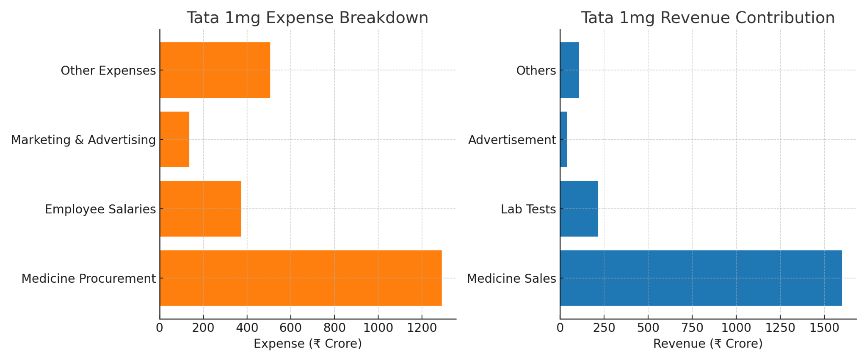

**Fig. 2: Revenue and Expense of Tata 1mg.**

**Customer Acquisition and Retention Channels:**

| **Category** | **Details** |
| --- | --- |
| **Customer Acquisition Channels** | **Referrals**: Word-of-mouth and referral programs.  **Online Searches (SEO & SEM)**: Google searches for medicines, diagnostics, and teleconsultations.  **Social Media Ads**: Facebook, Instagram, and YouTube promotions.  **Performance Marketing**: Paid Google Ads, app install campaigns, and affiliate partnerships.  **Corporate Tie-ups:** Employee healthcare plans with companies. |
| **Effectiveness of Acquisition Channels** | **SEO & SEM (30%)**: Highly effective due to intent-driven searches; customers actively looking for medicines or lab tests.  **Referral Programs (20%)**: Encourages organic growth at lower costs; customer trust is a key driver.  **Social Media Ads (25%)**: Effective but has higher acquisition costs; works well for brand awareness.  **Corporate Tie-ups (15%)**: Recurring revenue but requires business development efforts.  **Performance Marketing (10%)**: Good for quick acquisition but expensive over time. |
| **Understanding Customer Behavior** | **Purchase Data Analysis**: Frequent Purchases- Chronic medication users form a loyal customer base. High Order Value-Customers buying health packages, supplements, and diagnostics tend to have a higher lifetime value.  **Customer Feedback**: Users value affordability, convenience, and fast delivery but demand better service in Tier 2 & 3 cities. |
| **Churn Analysis** | **Reasons for Churn**: Price Sensitivity-Customers switch to competitors offering lower prices or discounts. Delivery Issues-Late deliveries, especially in non-metro regions. Customer Support Experience-Delays in resolving issues can lead to churn.  **Churn Reduction Strategies**: Personalized discounts based on purchase history. AI-powered delivery optimization to reduce delays. Improved customer service with faster resolution times. |
| **Retention Rates & Loyalty Factors** | Tata 1mg’s estimated customer retention rate is ~**70%.**  **Discounts & Cashback Offers**: Encourages repeat purchases. **Subscription Models**: Ensures steady recurring customers. **Personalized Health Recommendations**: AI-driven suggestions for medicines and health checkups. **Improved UX & Reminders**: Auto-refill options and prescription reminders enhance retention. |

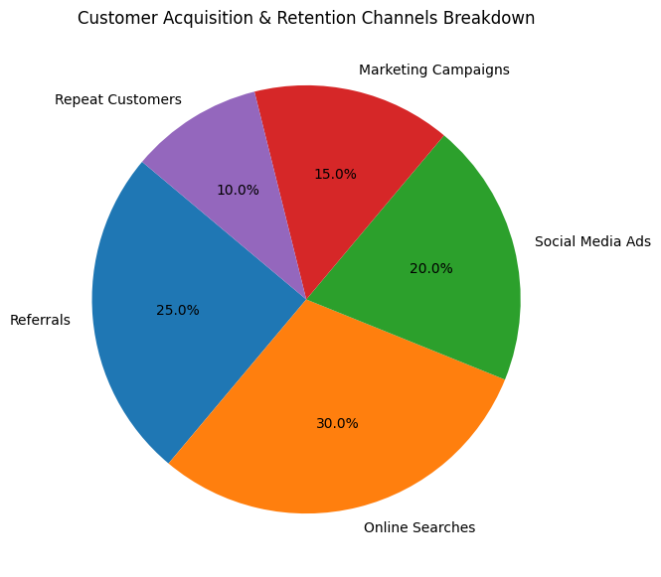

**Fig. 3: Customer Acquisition & Retention Channels of Tata 1mg.**

**II**. **Focus Areas for Increasing Tata 1mg's Profit by 25%**

To boost Tata 1mg’s profit by 25%, the company needs to strategically concentrate on several critical areas. These include **internal operations, product development strategies, market expansion, post-sales management, and branding**. By targeting these areas with focused initiatives, Tata 1mg can improve operational efficiency, enhance customer satisfaction, and expand its market presence.

| **Category** | **Focus Area** | **Measures** |
| --- | --- | --- |
| **Internal Operations**  **~ 9%** | **Process Optimization**  **~ 7%** | **Quality Control:** Implement quality control measures to ensure products and services meet high standards. This reduces errors, rework, and customer complaints, which improves overall efficiency. |
| **Process Optimization:** Analyze and refine workflows to eliminate bottlenecks, reduce redundant steps, and streamline operations. Implement automation where possible to increase speed and accuracy. |
| **Cost Control:** Identify and cut unnecessary expenses. This could involve renegotiating supplier contracts, optimizing inventory levels, and reducing waste. |
| **Human Resource Management**  **~ 2 %** | **Training and Development:** Invest in regular training to improve skills and efficiency. Well-trained employees are more productive and make fewer mistakes, lowering costs. |
| **Strategic Hiring:** Focus on hiring skilled employees who match the company’s needs. Efficient hiring practices ensure you bring in the right talent without increasing unnecessary costs. |
| **Performance Management:** Use performance management systems to set goals, provide feedback, and assess performance. Recognize and reward high performers to motivate the team. |
| **Logistics and Operations Management**  **~ 4 %** | **Supplier Coordination**  **~ 2.5%** | Enhance supplier relationships by negotiating better terms and ensuring reliable supply sources. Focus on improving procurement processes to reduce costs. |
|  | **Logistics Optimization**  **~ 1.5 %** | Streamline transportation, warehousing, and inventory management to improve efficiency and lower costs. Aim for faster, more reliable delivery performance. |
| **Product Development**  **~3 %** | **Product Optimization**  **~ 2%**    **Product Design**  **~1%** | **Cut Down Underperforming Products:** Discontinue products that do not meet sales or profitability targets. Focus resources on more successful products to improve overall performance. |
| **Launch Combo Products:** Tata 1Mg could introduce a combo package that includes essential health products such as a multivitamin, a health supplement, and a personalized health check-up at a discounted rate. This combo would offer customers value and convenience, encouraging them to purchase multiple items in one go and making it easier for them to maintain their health |
| **Market Expansion**  **~ 4** | **Regional Expansion**  **~ 1%** | **New Markets:** Extend reach to new regions or countries to tap into underserved markets and increase overall sales. For instance, opening new stores or setting up delivery services in smaller towns or new cities. |
| **Market Penetration**  **~ 3%** | **Local Market Expansion Strategy:** Increase market share within existing regions by targeting new customer segments or enhancing current offerings. This could involve launching local advertising campaigns, expanding product lines, or improving in-store experiences to attract more customers. |
| **Post-Sales Management**  **~ 2%** | **Customer Satisfaction**  **~ 1%** | **Customer Feedback:** Collect and analyze feedback to understand customer needs and preferences. Use this data to make improvements and tailor services to better meet customer expectations. |
| **Customer Service:** Provide responsive and effective customer support to address issues and inquiries. Ensure quick resolution and maintain high service standards to enhance overall customer satisfaction. |
| **Customer Retention**  **~ 1%** | **Loyalty Programs:** Keep existing customers engaged and loyal by offering personalized follow-ups and utilizing Circle Membership benefits. Provide discounts and rewards to encourage repeat business and strengthen long-term relationships. |
| **Branding and Marketing**  **~ 3 %** | **Brand Visibility**  **~ 1.5%** | **Digital Marketing:** Implement targeted campaigns across social media, email, and other online platforms to increase your brand's reach and engagement with potential customers. |
| **SEO:** Optimize website and online content to improve search engine rankings, driving more organic traffic and boosting brand awareness. |
| **Partnerships**  **~ 0.5%** | Collaborate with health influencers to leverage their audience and increase your brand’s visibility through authentic endorsements and promotions of healthcare and beauty products. |
| **Word of Mouth and Referrals**  **~ 1%** | **Referral Programs:** Implement referral programs that reward existing customers for bringing in new ones. Offer incentives such as discounts or credits for each successful referral. This approach leverages satisfied customers to expand your customer base cost-effectively. |
| **Positive Reviews:** Encourage satisfied customers to leave positive reviews on platforms like Google and social media. Highlight these reviews on your website and marketing materials to build trust with potential customers. Positive reviews enhance credibility and attract new clients. |

By focusing on internal Operations, logistics and operations management, product development strategy, market expansion, post-sales management, and branding & marketing, Tata 1mg can strategically enhance its profitability by 25%. Adopting these strategies will not only drive higher profits but also reinforce Tata 1mg’s competitive stance in the market.

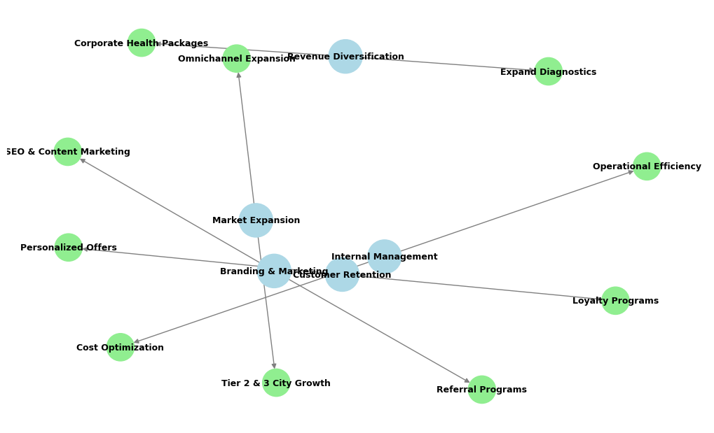

**Fig. 4: Growth Strategy Framework**

**III. Defining Strategies**

| **Category** | **Details** |
| --- | --- |
| **Optimize Expenses** | **Cost Reduction:** Implement measures to reduce operational costs, such as negotiating better terms with suppliers, streamlining logistics, and adopting cost-effective technologies. Renegotiate contracts with pharmaceutical suppliers for bulk discounts and better terms. Optimise delivery routes to reduce fuel costs and delivery times. |
| **Efficiency Improvements:** Use data analytics to optimise inventory management, reduce waste, and streamline operations. |
| **Enhance Revenue Streams** | **Leverage Digital Marketing:** Optimize your website and app for search engines (SEO) to appear in the top results for relevant queries such as “buy medicines online” or “book lab tests.” Use targeted ads on Google and social media platforms like Facebook and Instagram to attract a wider audience. |
| **Partnerships with Doctors and Hospitals:** Build partnerships with doctors, clinics, and hospitals to recommend your platform for purchasing medicines or booking lab tests. You could offer special discounts or packages to their patients, helping them find a reliable service. |
| **Expand Lab Test Network and Home Services:** Expand your lab test collection network to cover more geographic areas and offer home collection services for blood samples and other tests. Highlight the convenience of getting tests done at home through advertising and in-app promotions. |
| **Improve Customer Satisfaction and Retention** | **Personalized Experiences:** Use customer purchase history and preferences to provide tailored product recommendations and exclusive discounts. Implement personalized health tips and medication reminders to improve user engagement. |
| **Loyalty Programs:** Launch a loyalty program where customers earn points for every purchase, which can be redeemed for discounts or free products. Offer additional points for referrals and social media engagement. |
| **Customer Feedback:** Regularly conduct surveys and feedback forms to gather customer opinions. Use this data to make informed decisions on product offerings and service enhancements. Implement a customer support chat feature on the app for real-time assistance. |

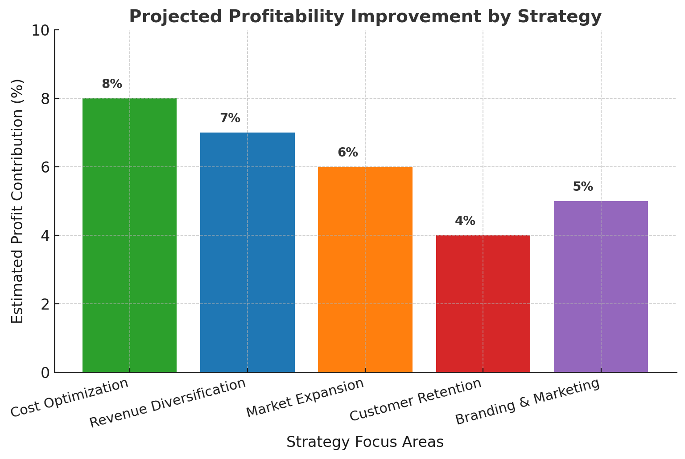

**Fig. 5: Profitability Improvement Chart**

To boost the profitability of Tata 1mg's healthcare, we have strategically implemented an inside-out approach. This begins with optimizing expenses, followed by enhancing customer satisfaction and retention, and finally expanding revenue streams. Each step is driven by data insights to ensure decisions are informed and effective. By focusing on these areas, Tata 1mg can achieve significant profit growth while maintaining exceptional standards of customer care and service. This comprehensive approach ensures that improvements are sustainable and aligned with the needs of modern healthcare consumers.

**PART - II**

**Guesstimates**

**Question 1:** Estimate a hospital's potential annual cost savings if it reduces its readmission rate by 10%.

### **Assumptions:**

1. **Total Monthly Consultations:** 10,000.
2. **Estimated Readmission Rate:** Since the exact rate is unavailable, we'll assume a typical readmission rate of **20%**.
3. **Average Consultation Cost:** ₹200.
4. **Target Readmission Rate Reduction:** **10%** relative reduction.

### **Calculation:**

1. **Current Monthly Readmissions:**

10,000×0.20=2,000

1. **New Monthly Readmissions After 10% Reduction:**

2,000×0.10=200

3. **Monthly Cost Savings:**

200×200=₹40,000

4. **Annual Cost Savings:**

₹40,000×12=₹4,80,000

### **Conclusion:**

### By reducing its **readmission rate by 10%**, Tata 1mg could potentially save around **₹4.8 lakh annually** in teleconsultation costs

**Question 2:** Estimate the potential annual revenue generated by a **Tata 1mg** if 20% of its consultations are shifted to telemedicine.

### 

### 

### **Assumptions:**

### **Total Monthly Consultations:** 1,00,000

1. **Percentage Shift to Telemedicine:** 20%
2. **Average Consultation Cost (Telemedicine):** ₹200 (Based on the range ₹50–₹500)

### **Calculation:**

1. **Monthly Telemedicine Consultations After Shift**:

1,00,000×0.20=20,000

1. Monthly Revenue from Telemedicine:

20,000×200=**₹40,00,000**

1. **Annual Revenue:**

₹40,00,000×12=₹4,80,00,000

### **Conclusion:**

If Tata 1mg shifts **20% of its consultations to telemedicine**, it could potentially generate **₹4.8 crore annually** from telemedicine consultations alone.

**Question 3:** Estimate the potential annual market size (in dollars) for a new medical device designed for diabetes management in India.

**Assumptions:**

**India’s diabetic population:** 77 million

**Target market (20% of diabetic patients):** 15.4 million

**Device cost:** $60

**Adoption rate in the first year:** 10%

**Calculation:**

**Potential users in the first year:** 1.6 million

**Market size:** 1.6 million × 60**:** $92.4 million annual market size

### 

### 

### **Conclusion:**

With a **device cost of $60** and **20% market penetration**, the **potential annual market size** for the diabetes management device in India would be approximately **$ 92.4 million**.

**Question 4:** Estimate the potential additional annual revenue for a clinic from implementing preventive care programs

**Assumptions:**

**Clinic has 1,20,000 patients annually**

P**reventive care program adoption rate:** 20%

**Average fee per preventive care program:** ₹2000

**Patients opting for at least 2 additional checkups:** 20% of adopters

**Additional checkup fee:** ₹100

**Calculation:**

**Revenue from preventive programs :** (20% of 120,000) × ₹200 = 24,000 × ₹2000 = ₹4,80,00,000

**Revenue from additional checkups :** (10% of 24,000) × ₹100 = 2400 × ₹100 = ₹2,40,000

**Total additional annual revenue:** ₹4,82,40,000

### **Conclusion:**

The clinic could generate **₹4,82,40,000** **annually** from participation fees and additional services by implementing preventive care programs.

**Question 5:** Estimate the potential annual cost savings for a **Tata 1mg** from optimizing its supply chain management.

**Assumptions:**

**Tata 1mg's Operating Revenue (FY24):** ₹1,968 crore

**Estimated Supply Chain Expenses:** Assuming supply chain costs constitute approximately 30% of operating revenue, the expenses would be:  
Supply Chain Expenses=30%×₹1,968 crore=₹590.4 crore

**Potential Savings through Optimization:** 15%

**Calculation:**

**Annual Cost Savings:** 15%×₹590.4 crore=₹88.56 crore

**Conclusion:**

By optimizing its supply chain management, **Tata 1mg** could potentially achieve annual cost savings of approximately **₹88.56 crore**, thereby enhancing operational efficiency and profitability.

**PART - III**

## **Cohort Retention Analysis for Tata 1mg**

Cohort analysis is essential for understanding patient engagement with Tata 1mg's online medicine delivery app. This report examines user retention, engagement trends, and strategies to improve long-term usage.

**Scenario Based Questions**

#### **Scenario 1:**

A healthcare company offers a **healthcare** app that helps patients track and manage conditions such as diabetes and hypertension. The company wants to analyze patient engagement with the app and understand how frequently patients continue using it after the first month.

**Question 1**:  
How would you conduct a **cohort retention analysis** to track the monthly usage of the app by patients who signed up in different months? What metrics would you focus on?

**Answer 1:**

We need to analyze the monthly retention rate of Tata 1mg users to understand how frequently patients continue using the app for tracking chronic conditions.

**Table 1: Assumed Data for Cohort Analysis**

| **Cohort** | **New Users** | **Month 1** | **Month 2** | **Month 3** | **Month 4** | **Month 5** |
| --- | --- | --- | --- | --- | --- | --- |
| Jan 2024 | 1000 | 600 | 500 | 400 | 300 | 250 |
| Feb 2024 | 1200 | 720 | 600 | 500 | 400 | 350 |
| Mar 2024 | 1500 | 900 | 750 | 620 | 500 | 420 |
| Apr 2024 | 1700 | 1020 | 880 | 700 | 600 | 500 |
| May 2024 | 1800 | 1080 | 950 | 780 | 650 | 560 |

Metrics to Focus On:

* **Monthly Retention Rate:** Measures the percentage of users who continue using the app each month.

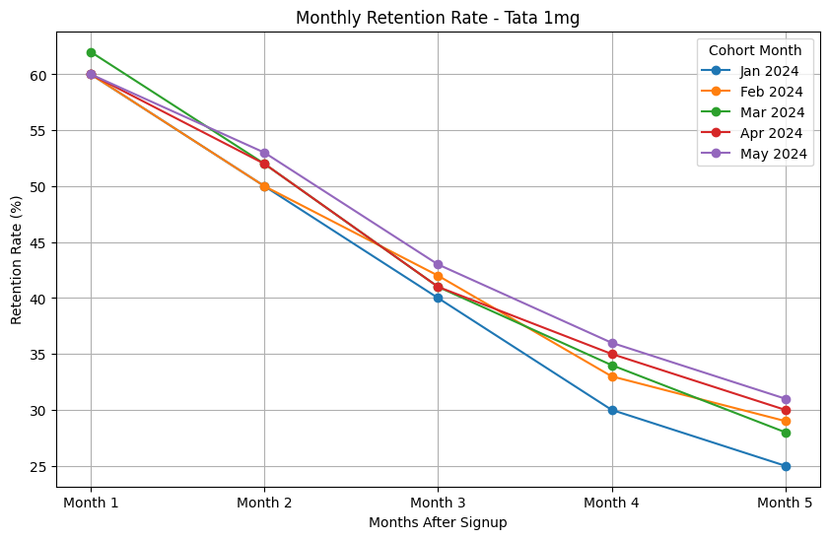

* **Churn Rate:** Identifies the percentage of users who stop using the app after a certain period. Below is the churn rate for January cohort.

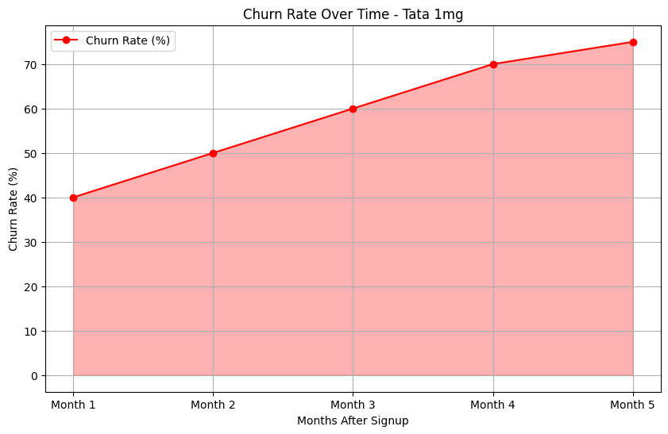

### **Average Retention Rate (%):** This metric gives an overall view of user retention across different cohorts. For example, the average retention rate for January cohort is 59%.

### **Insights from the Cohort Analysis**

### Retention is highest in the first month (~60%) but declines over time, stabilizing around 30% by Month 5.

### Churn rate increases over time, showing that efforts are needed to improve long-term engagement.

### May 2024 cohort has the best Month 5 retention (31.1%), indicating potential improvements in engagement strategies.

### Improving retention in early months (Month 1 & 2) is crucial for long-term user loyalty.

**Question 2**:  
If you notice that retention rates drop significantly after the second month, what might be some reasons for the drop-off, and how could the company improve retention?

**Answers 2:**

Potential Reasons for Drop-off:

* **Lack of Engagement:** Users may feel that they have consumed all the valuable content or features available within the app, leading to decreased interest. If the app does not offer new or varied experiences, users may lose motivation to continue using it.
* **Complexity or Usability Issues:** If users find the app challenging to navigate or understand, they may stop using it. Bugs or glitches can frustrate users and drive them away.
* **Insufficient Personalization:** If the app does not tailor information or reminders based on individual patient needs, users may feel disconnected from the app.

### Strategies to Improve Retention:

* **Enhance Engagement:** Introduce new features, educational content, or challenges to keep users interested. Implement gamification elements, such as rewards for achieving health goals or milestones, to encourage consistent usage.
* **Improve User Experience:** Conduct usability tests to identify pain points and improve navigation. Regularly solicit feedback to understand user pain points and make necessary adjustments.
* **Personalization:** Use algorithms to personalize content, reminders, and recommendations based on user behavior and preferences. Allow users to customize their dashboards to prioritize the metrics that matter most to them.

## **A/B Testing for Tata 1mg**

#### **Scenario 2:**

The healthcare company is testing the effectiveness of **personalised health insights** for patients with chronic conditions. **Version A** provides general health advice, while **Version B** offers personalised insights based on the patient’s medical history and recent test results. The company wants to measure the impact of these insights on **patient engagement**.

**Question 1**:  
Design an **A/B test** to evaluate whether personalised health insights lead to higher patient engagement compared to general health advice. What metrics would you track to determine success?

**Answer 1**:

We need to determine if personalized health insights (Version B) lead to higher patient engagement compared to general health advice (Version A).

Metrics to Track:

* **Login Frequency:** Measures how often users log in after receiving health insights. Higher frequency = More engagement.
* **Time Spent per Session:** Tracks the average time users spend reading insights. More time = Higher interest in content.
* **Click-Through Rate (CTR)**: % of users clicking on articles, insights, or recommended content. Higher CTR = More engagement with recommendations.
* **Health Action Rate**: Measures how many users book doctor consultations or order medications after viewing insights. Higher rate = Personalized insights driving action.
* **Feature Engagement Rate**: % of users engaging with interactive features like symptom tracking, reminders. Higher rate = More interest in app features.
* **Retention Rate**: % of users still using the app after 1 & 2 months. Lower retention = Need for better personalization.
* **Net Promoter Score (NPS)**: Measures patient satisfaction and likelihood to recommend the app. Higher NPS = Users find personalized insights valuable.

**Table 2: Assumed Data for A/B Testing**

| **Metric** | **Version A (General Advice)** | **Version B (Personalized Insights)** | **% Difference** |
| --- | --- | --- | --- |
| **Login Frequency (per month)** | **8** | **12** | **+50%** |
| **Avg. Time per Session (mins)** | **5** | **8** | **+60%** |
| **Click-Through Rate (CTR)** | **12%** | **25%** | **+108%** |
| **Health Action Rate** | **10%** | **18%** | **+80%** |
| **Feature Engagement** | **22%** | **35%** | **+59%** |
| **Retention Rate (60 days)** | **50%** | **70%** | **+40%** |
| **Net Promoter Score (NPS)** | **6.5** | **8.2** | **+26%** |

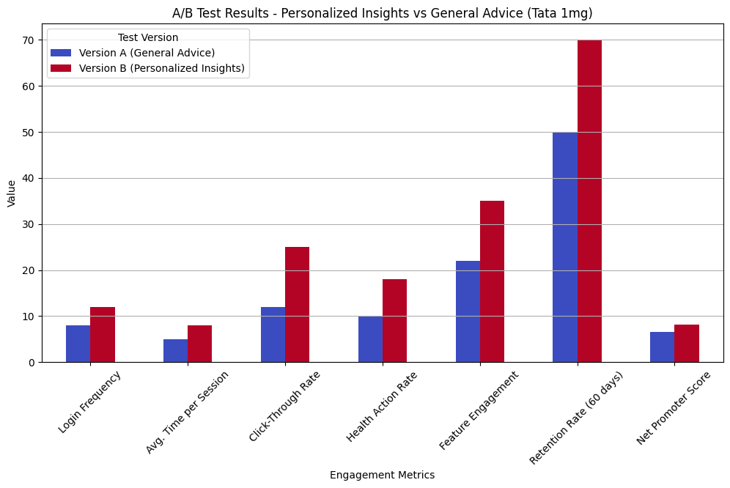

**Question 2**:  
If **Version B** (personalised insights) leads to higher engagement but also results in more support requests from patients seeking clarification on their health insights, how would you interpret this outcome, and what recommendations would you give?

**Answers 2:**

Interpretation of the Outcome:

* **Higher Engagement:** The increased engagement shows that personalized health insights are resonating with patients. This suggests that providing more relevant, tailored information is driving patients to interact more frequently with the platform, which is the intended outcome.
* **Increased Support Requests:** The rise in support requests likely indicates that while personalized insights are more engaging, they may also be more complex or confusing for some patients. Patients may have difficulty understanding the tailored recommendations, medical terms, or how to act on the insights provided.

Recommendations:

* **Improve Clarity of Insights:** Review the language and complexity of the personalized health insights. Simplify medical jargon, use more patient-friendly language, and provide clear action steps or explanations where needed.
* **Integrated Support Options:** Integrate more streamlined support channels within the platform, such as live chat, automated chatbots for common queries, or direct links to book appointments with healthcare providers if needed.

**Conclusion:**

* Higher engagement is a great outcome, but support requests indicate a gap in understanding.
* The goal is to maintain engagement while reducing confusion . By simplifying insights, adding actionability, and integrating AI-powered assistance, Tata 1mg can enhance user experience and reduce unnecessary support queries.

**References:**

1. <https://entrackr.com/2024/07/tata-1mgs-revenue-nears-rs-2000-cr-in-fy24-losses-down-by-75/>
2. <https://startuptalky.com/1mg-success-story/#Tata_1mg-RevenueandGrowth>
3. <https://www.thearcweb.com/article/tata-1mgs-losses-narrow-75-revenue-rises-21-Kfp6LgYzrlJpaPxO>
4. <https://www.tata.com/content/dam/tata/pdf/fy24/Tata-Sons-Annual-Report-FY24.pdf>
5. <https://www.smarther.co/mobile-apps/online-medicine-apps-india/>
6. <https://www.who.int/india/health-topics/diabetes>
7. <https://link.springer.com/article/10.1007/s41669-019-00176-9>
8. https://www.productmonk.io/p/1mg-success-strategy